*To have a better idea of the website (due to a few problems with some browsers) please download the folder.*

*You can still edit the word document in Dropbox.*

*======================================================= Some of the information that is in this document has already been given to you in the e-mail containing the link to this folder.*

*___________________________________________________________________________*

*For modifying one of the backgrounds in the website please indicate the part of the web background:*

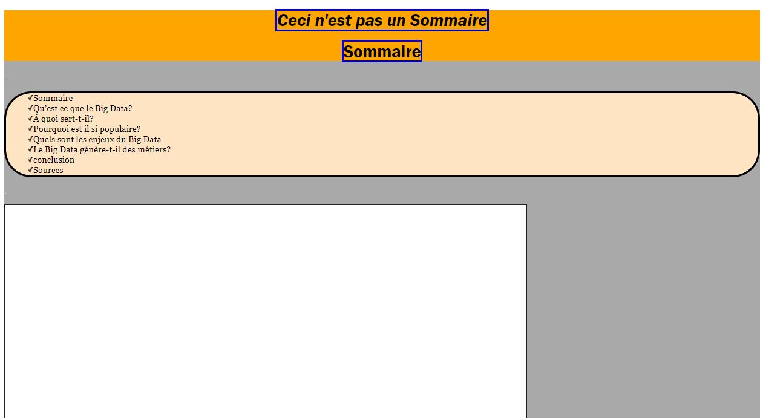

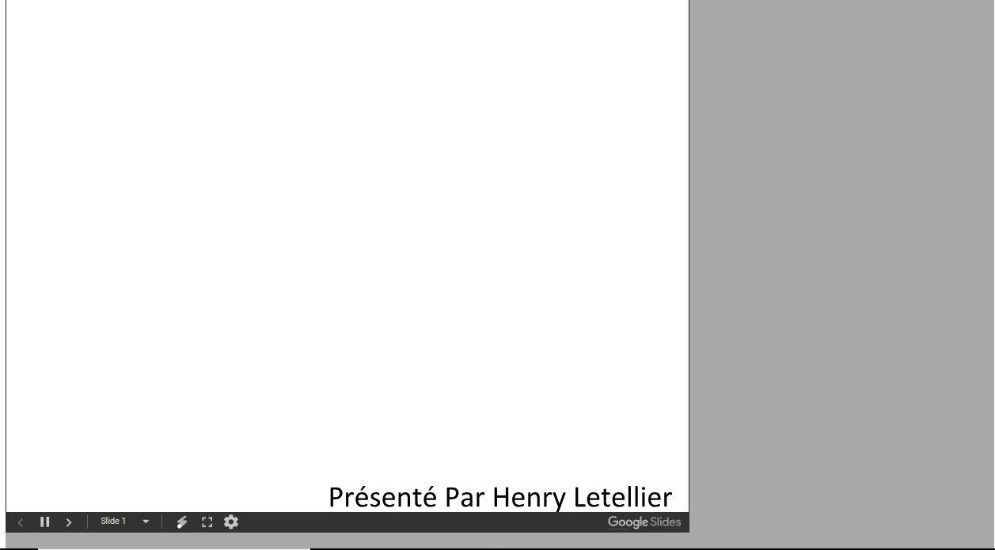



*The syntax to speak about the background is: background + the part to be modified + the link to the image or the code of the html colour.*

*For example (for a colour): background body colour #FFFFF*

*For an image: background footer* "<https://s1.qwant.com/thumbr/0x0/3/9/63cef3016d29d5bc7e986a1b2417dfb6e772c98df05f1ef66242c37d6b352f/ikb69.jpg?u=https%3A%2F%2Fdianeart.files.wordpress.com%2F2013%2F08%2Fikb69.jpg&q=0&b=1&p=0&a=1> "

For the colour of one of the elements in the web-page (the writing, the colour of the boxes) please: "write the text that it contains or the text itself" + colour= "the colour that you have chosen if or the image (the image does not work with writing)"

For example: Pages + colour=*#FFFFF*

*Or if it is an image: box "précédent" + box colour=#FFFFF or image="*<https://s1.qwant.com/thumbr/0x0/3/9/63cef3016d29d5bc7e986a1b2417dfb6e772c98df05f1ef66242c37d6b352f/ikb69.jpg?u=https%3A%2F%2Fdianeart.files.wordpress.com%2F2013%2F08%2Fikb69.jpg&q=0&b=1&p=0&a=1> "

*___________________________________________________________________________*

*For text: type the old text + replace by + the replacement text*

*For example: "Pages" to be replaced by " salut"*

*__________________________________________________________________________*

*For the size of the boxes please say the name of the box or what it contains + height + width*

*For example: boite "suivant" height =5 width=7*

*(if you only want to modify one of the two elements (height or width) and leave the other one empty).*

*__________________________________________________________________________*

*If it is an image to be modified: "image or name of image" + to be replaced + "image link"*

*For example: "tick" to be replaced by "*[*https://s1.qwant.com/thumbr/0x0/9/6/86dbaa96b477a90e2043e932d2e419735d2dcef5b459277a5a1c89d508700b/explorer-windows-55_full.jpg?u=http%3A%2F%2Fwww.zebulon.fr%2Fmedias%2Fimages%2Fdossiers%2Ffull%2Fexplorer-windows-55_full.jpg&q=0&b=1&p=0&a=1*](https://s1.qwant.com/thumbr/0x0/9/6/86dbaa96b477a90e2043e932d2e419735d2dcef5b459277a5a1c89d508700b/explorer-windows-55_full.jpg?u=http%3A%2F%2Fwww.zebulon.fr%2Fmedias%2Fimages%2Fdossiers%2Ffull%2Fexplorer-windows-55_full.jpg&q=0&b=1&p=0&a=1)*"*

*=======================================================*

*Please leave here the comments and modifications to do on the pages*

*PS: for the moment only, the page "sommaire" is up to date*

Please leave your comments below this line:

|  |
| --- |
|  |

* <https://handisport35.org/wp-content/uploads/2017/11/logo-site-internet.png>